Composition

Definition
# Source: AI Source: Provided by: [Data Path: Persons Table -> ID Column: 1, Name_En Column: Motasem Essam] -> From: [ChatGPT] on [7/25/2026]
In geometry, Composition is the process of applying two or more geometric transformations successively to the same figure.
If transformation $T_{1}$is followed by transformation $T_{2}$, the resulting transformation is written:
$$\boxed{T_{2}∘T_{1}}$$
and means:
$$P\underset{→}{T_{1}}P^{'}\underset{→}{T_{2}}P^{''}$$
Therefore:
$$\boxed{\left(T_{2}∘T_{1}\right)\left(P\right)=T_{2}\left(T_{1}\left(P\right)\right)}$$
The transformation applied first is written on the right.
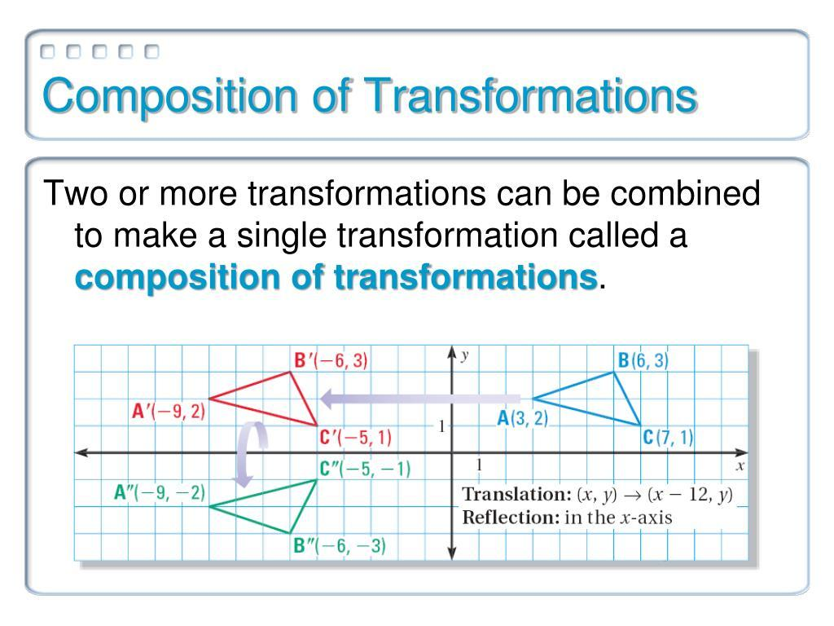
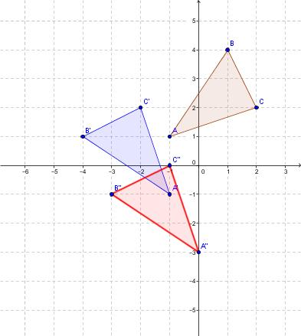
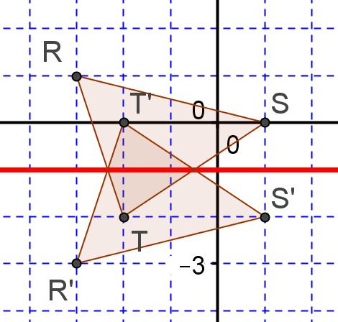
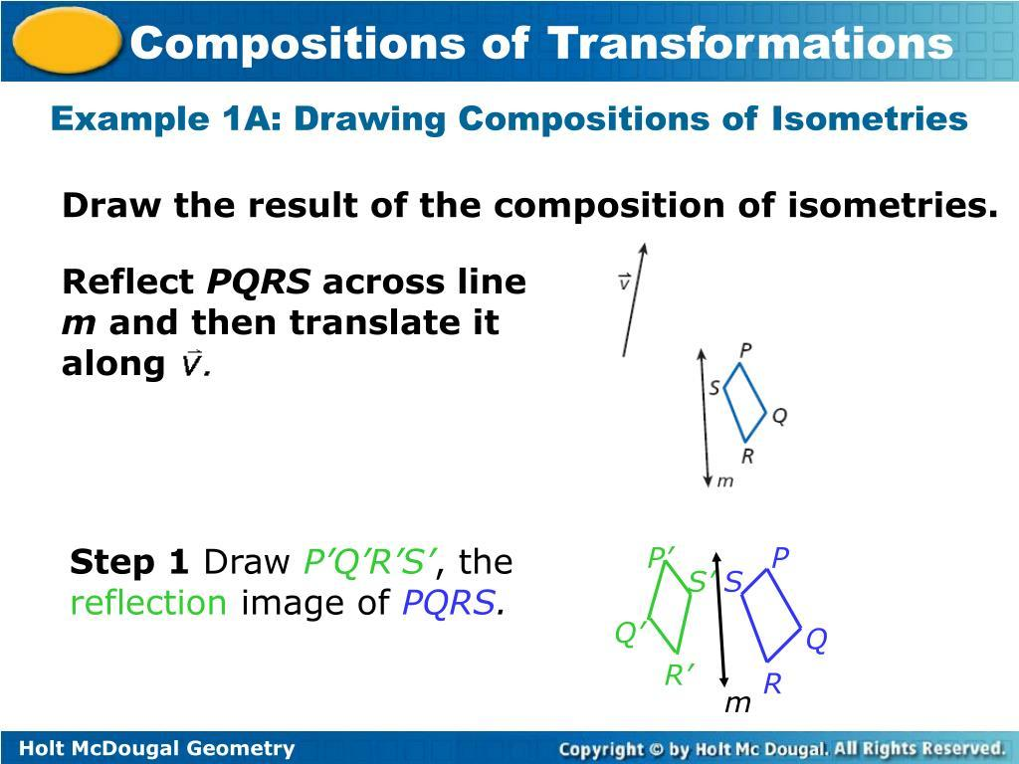
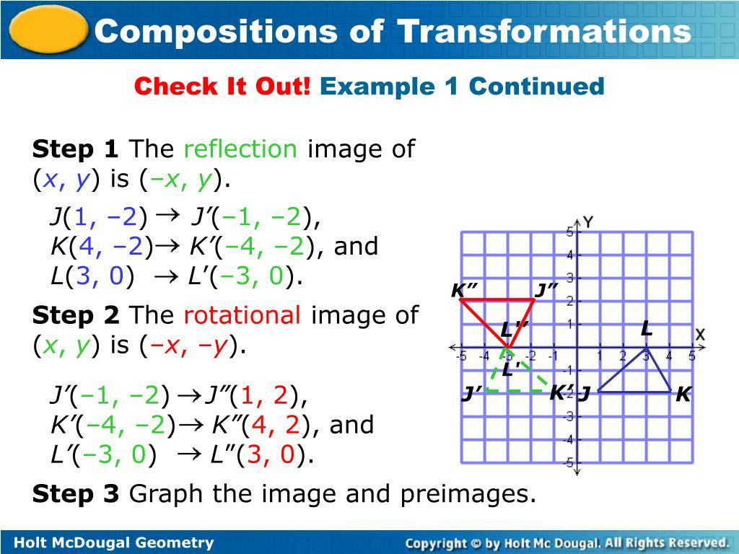

Fundamental Concept
# Source: AI Source: Provided by: [Data Path: Persons Table -> ID Column: 1, Name_En Column: Motasem Essam] -> From: [ChatGPT] on [7/25/2026]
A composition combines transformations into a single overall transformation.
For example:
$$\text{Translation}→\text{Rotation}$$
can be represented as:
$$\boxed{R∘T}$$
because the translation $T$happens first and the rotation $R$happens second.
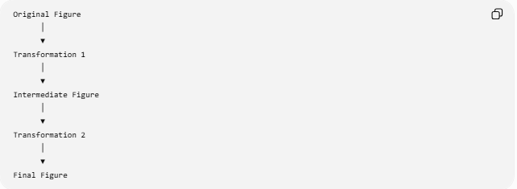
Original Figure
│
▼
Transformation 1
│
▼
Intermediate Figure
│
▼
Transformation 2
│
▼
Final Figure

Basic Structure
# Source: AI Source: Provided by: [Data Path: Persons Table -> ID Column: 1, Name_En Column: Motasem Essam] -> From: [ChatGPT] on [7/25/2026]
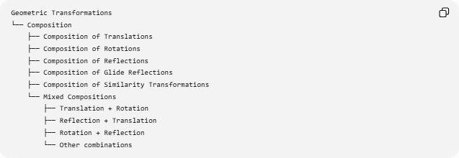
Geometric Transformations
└── Composition
├── Composition of Translations
├── Composition of Rotations
├── Composition of Reflections
├── Composition of Glide Reflections
├── Composition of Similarity Transformations
└── Mixed Compositions
├── Translation + Rotation
├── Reflection + Translation
├── Rotation + Reflection
└── Other combinations

Mathematical Representation
# Source: AI Source: Provided by: [Data Path: Persons Table -> ID Column: 1, Name_En Column: Motasem Essam] -> From: [ChatGPT] on [7/25/2026]
If:
$$T_{1}$$
is followed by:
$$T_{2}$$
then:
$$\boxed{T=T_{2}∘T_{1}}$$
For a point $P$:
$$\boxed{T\left(P\right)=T_{2}\left(T_{1}\left(P\right)\right)}$$
For three transformations:
$$P\underset{→}{T_{1}}P^{'}\underset{→}{T_{2}}P^{''}\underset{→}{T_{3}}P^{'''}$$
the composition is:
$$\boxed{T_{3}∘T_{2}∘T_{1}}$$

Order Matters
# Source: AI Source: Provided by: [Data Path: Persons Table -> ID Column: 1, Name_En Column: Motasem Essam] -> From: [ChatGPT] on [7/25/2026]
Composition of transformations is generally not commutative.
In general:
$$\boxed{T_{2}∘T_{1}≠T_{1}∘T_{2}}$$
This means that changing the order of transformations can produce a different result.
Example
Translate a point and then rotate it:
$$R∘T$$
is generally different from rotating it and then translating it:
$$T∘R$$
Therefore:
$$\boxed{\text{Order of transformations is important}}$$

Composition of Translations
# Source: AI Source: Provided by: [Data Path: Persons Table -> ID Column: 1, Name_En Column: Motasem Essam] -> From: [ChatGPT] on [7/25/2026]
Suppose:
$$T_{1}:\left(x , y\right)→\left(x , +ay+b\right)$$
and:
$$T_{2}:\left(x , y\right)→\left(x , +cy+d\right)$$
Applying both gives:
$$\left(x , y\right)→\left(x , +ay+b\right)$$
then:
$$\left(x , +a+cy+b+d\right)$$
Therefore:
$$\boxed{T_{2}∘T_{1}:\left(x , y\right)→\left(x , +a+cy+b+d\right)}$$
The two translations combine into a single translation:
$$\boxed{\left(a , b\right)+\left(c , d\right)=\left(a , +cb+d\right)}$$

Example — Translation Composition
# Source: AI Source: Provided by: [Data Path: Persons Table -> ID Column: 1, Name_En Column: Motasem Essam] -> From: [ChatGPT] on [7/25/2026]
Start with:
$$P=\left(2 , 3\right)$$
First translate by:
$$\left(4 , 1\right)$$
giving:
$$P^{'}=\left(6 , 4\right)$$
Then translate by:
$$\left(- , 25\right)$$
giving:
$$P^{''}=\left(4 , 9\right)$$
The combined translation is:
$$\left(4 , 1\right)+\left(- , 25\right)=\left(2 , 6\right)$$
Therefore:
$$\boxed{P^{''}=\left(2 , +23+6\right)=\left(4 , 9\right)}$$

Composition of Rotations
# Source: AI Source: Provided by: [Data Path: Persons Table -> ID Column: 1, Name_En Column: Motasem Essam] -> From: [ChatGPT] on [7/25/2026]
Two rotations about the same center combine into a single rotation.
If:
$$R_{O,α}$$
is followed by:
$$R_{O,β}$$
then:
$$\boxed{R_{O,β}∘R_{O,α}=R_{O,α+β}}$$
where the angles are interpreted with their signs.
Example
A ${30}^{∘}$rotation followed by a ${50}^{∘}$rotation about the same center gives:
$${30}^{∘}+{50}^{∘}={80}^{∘}$$
Therefore:
$$\boxed{R_{O,{50}^{∘}}∘R_{O,{30}^{∘}}=R_{O,{80}^{∘}}}$$

Composition of Reflections
# Source: AI Source: Provided by: [Data Path: Persons Table -> ID Column: 1, Name_En Column: Motasem Essam] -> From: [ChatGPT] on [7/25/2026]
The result depends on the relationship between the reflection lines.

1-Same Reflection Line
# Source: AI Source: Provided by: [Data Path: Persons Table -> ID Column: 1, Name_En Column: Motasem Essam] -> From: [ChatGPT] on [7/25/2026]
Reflecting twice across the same line returns the original figure:
$$\boxed{R_{l}∘R_{l}=I}$$
where $I$is the identity transformation.

2-Parallel Reflection Lines
# Source: AI Source: Provided by: [Data Path: Persons Table -> ID Column: 1, Name_En Column: Motasem Essam] -> From: [ChatGPT] on [7/25/2026]
The composition of reflections across two distinct parallel lines is a translation.
If the distance between the parallel lines is $d$, the translation distance is:
$$\boxed{2d}$$
in the direction from the first reflection line toward the second.
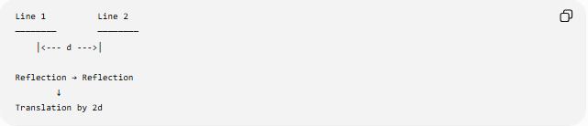
Line 1 Line 2
──────── ────────
│<--- d --->│

Reflection → Reflection
↓
Translation by 2d

3-Intersecting Reflection Lines
# Source: AI Source: Provided by: [Data Path: Persons Table -> ID Column: 1, Name_En Column: Motasem Essam] -> From: [ChatGPT] on [7/25/2026]
The composition of reflections across two intersecting lines is a rotation.
If the lines intersect at angle $θ$, the resulting rotation has angle:
$$\boxed{2θ}$$
about their intersection point.
$$\boxed{R_{l_{2}}∘R_{l_{1}}=R_{O,2θ}}$$
where $O$is the intersection of the two lines.

Composition of a Reflection and Translation
# Source: AI Source: Provided by: [Data Path: Persons Table -> ID Column: 1, Name_En Column: Motasem Essam] -> From: [ChatGPT] on [7/25/2026]
A reflection followed by a translation parallel to the reflection line produces a:
$$\boxed{\text{Glide Reflection}}$$
Thus:
$$\boxed{T_{\vec{v}}∘R_{l}=\text{Glide Reflection}}$$
when:
$$\vec{v}∥l$$
This connects composition directly with the previous topic.

Composition of Similarity Transformations
# Source: AI Source: Provided by: [Data Path: Persons Table -> ID Column: 1, Name_En Column: Motasem Essam] -> From: [ChatGPT] on [7/25/2026]
The composition of two similarity transformations is itself a similarity transformation.
If:
$$S_{1}$$
has scale factor $k_{1}$, and:
$$S_{2}$$
has scale factor $k_{2}$, then the combined scale factor is:
$$\boxed{k=k_{1}k_{2}}$$
provided the transformations are composed in the usual similarity framework.

Composition of Homotheties
# Source: AI Source: Provided by: [Data Path: Persons Table -> ID Column: 1, Name_En Column: Motasem Essam] -> From: [ChatGPT] on [7/25/2026]
For two homotheties with the same center $O$:
$$H_{O,k_{1}}$$
followed by:
$$H_{O,k_{2}}$$
the result is:
$$\boxed{H_{O,k_{2}}∘H_{O,k_{1}}=H_{O,k_{1}k_{2}}}$$
Example:
$$k_{1}=2, k_{2}=3$$
Then:
$$k=2\left(3\right)=6$$
so the composition is a homothety with scale factor:
$$\boxed{6}$$

Coordinate Composition
# Source: AI Source: Provided by: [Data Path: Persons Table -> ID Column: 1, Name_En Column: Motasem Essam] -> From: [ChatGPT] on [7/25/2026]
Suppose:
$$T_{1}:\left(x , y\right)→\left(x , +3y+2\right)$$
followed by a reflection across the $x$-axis:
$$T_{2}:\left(x , y\right)→\left(x , -y\right)$$
The composition is:
$$\left(x , y\right)→\left(x , +3y+2\right)$$
then:
$$\left(x , +3y+2\right)→\left(x , +3-y-2\right)$$
Therefore:
$$\boxed{\left(T_{2}∘T_{1}\right)\left(x , y\right)=\left(x , +3-y-2\right)}$$

Composition and Isometries
# Source: AI Source: Provided by: [Data Path: Persons Table -> ID Column: 1, Name_En Column: Motasem Essam] -> From: [ChatGPT] on [7/25/2026]
If the transformations being composed are all isometries, their composition is also an isometry.
Therefore:
$$\boxed{\text{Isometry}∘\text{Isometry}=\text{Isometry}}$$
For example:
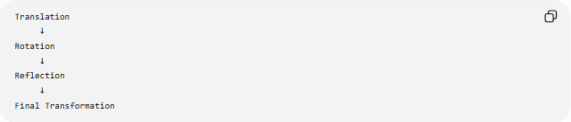
Translation
↓
Rotation
↓
Reflection
↓
Final Transformation
The resulting transformation still preserves distances.

Composition and Congruence
# Source: AI Source: Provided by: [Data Path: Persons Table -> ID Column: 1, Name_En Column: Motasem Essam] -> From: [ChatGPT] on [7/25/2026]
Because congruence transformations are isometries:
$$\boxed{\text{Congruence}∘\text{Congruence}=\text{Congruence}}$$
Therefore, applying several congruence transformations still produces a figure congruent to the original.

Composition and Similarity
# Source: AI Source: Provided by: [Data Path: Persons Table -> ID Column: 1, Name_En Column: Motasem Essam] -> From: [ChatGPT] on [7/25/2026]
Similarly:
$$\boxed{\text{Similarity}∘\text{Similarity}=\text{Similarity}}$$
However, unlike congruence, the resulting transformation may change the size of the figure.
If the scale factors are $k_{1}$and $k_{2}$:
$$\boxed{k=k_{1}k_{2}}$$

Identity Transformation
# Source: AI Source: Provided by: [Data Path: Persons Table -> ID Column: 1, Name_En Column: Motasem Essam] -> From: [ChatGPT] on [7/25/2026]
The identity transformation $I$leaves every point unchanged:
$$\boxed{I\left(P\right)=P}$$
It acts as the neutral element of composition:
$$\boxed{T∘I=I∘T=T}$$
For example, two reflections across the same line produce the identity:
$$\boxed{R_{l}∘R_{l}=I}$$

Inverse Transformation
# Source: AI Source: Provided by: [Data Path: Persons Table -> ID Column: 1, Name_En Column: Motasem Essam] -> From: [ChatGPT] on [7/25/2026]
Every reversible geometric transformation has an inverse transformation.
The inverse reverses the effect of the original transformation.
$$\boxed{T^{-1}∘T=I}$$
and:
$$\boxed{T∘T^{-1}=I}$$
Examples:
Translation
Translation by $\left(a , b\right)$:
$$T_{\left(a , b\right)}$$
has inverse:
$$T_{\left(- , a-b\right)}$$
Rotation
Rotation by $θ$:
$$R_{θ}$$
has inverse:
$$R_{-θ}$$
Reflection
A reflection is its own inverse:
$$\boxed{R_{l}^{-1}=R_{l}}$$

Composition Table
# Source: AI Source: Provided by: [Data Path: Persons Table -> ID Column: 1, Name_En Column: Motasem Essam] -> From: [ChatGPT] on [7/25/2026]
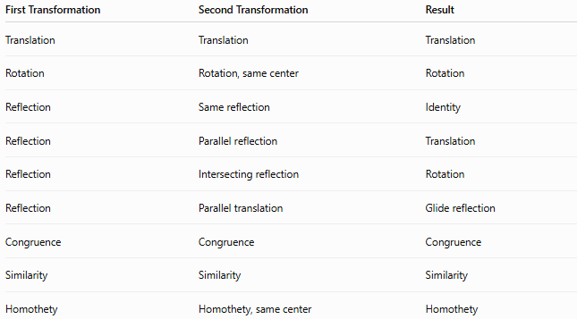
First Transformation | Second Transformation | Result
Translation | Translation | Translation
Rotation | Rotation, same center | Rotation
Reflection | Same reflection | Identity
Reflection | Parallel reflection | Translation
Reflection | Intersecting reflection | Rotation
Reflection | Parallel translation | Glide reflection
Congruence | Congruence | Congruence
Similarity | Similarity | Similarity
Homothety | Homothety, same center | Homothety

Transformation Composition Tree
# Source: AI Source: Provided by: [Data Path: Persons Table -> ID Column: 1, Name_En Column: Motasem Essam] -> From: [ChatGPT] on [7/25/2026]
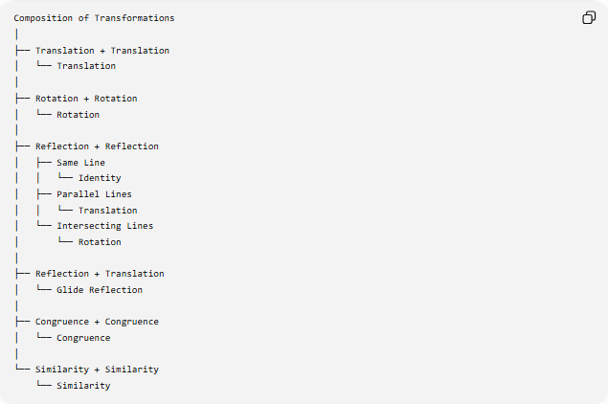
Composition of Transformations
│
├── Translation + Translation
│ └── Translation
│
├── Rotation + Rotation
│ └── Rotation
│
├── Reflection + Reflection
│ ├── Same Line
│ │ └── Identity
│ ├── Parallel Lines
│ │ └── Translation
│ └── Intersecting Lines
│ └── Rotation
│
├── Reflection + Translation
│ └── Glide Reflection
│
├── Congruence + Congruence
│ └── Congruence
│
└── Similarity + Similarity
└── Similarity

Important Properties
# Source: AI Source: Provided by: [Data Path: Persons Table -> ID Column: 1, Name_En Column: Motasem Essam] -> From: [ChatGPT] on [7/25/2026]
Composition is associative
For transformations $T_{1},T_{2},T_{3}$:
$$\boxed{\left(T_{3}∘T_{2}\right)∘T_{1}=T_{3}∘\left(T_{2}∘T_{1}\right)}$$
Composition is generally not commutative
$$\boxed{T_{2}∘T_{1}≠T_{1}∘T_{2}}$$
Identity
$$\boxed{T∘I=I∘T=T}$$
Inverse
$$\boxed{T^{-1}∘T=I}$$

Classification
# Source: AI Source: Provided by: [Data Path: Persons Table -> ID Column: 1, Name_En Column: Motasem Essam] -> From: [ChatGPT] on [7/25/2026]
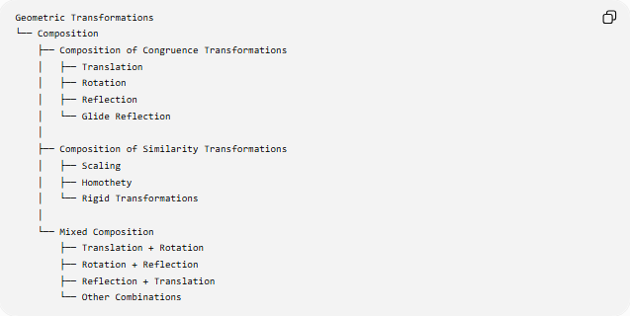
Geometric Transformations
└── Composition
├── Composition of Congruence Transformations
│ ├── Translation
│ ├── Rotation
│ ├── Reflection
│ └── Glide Reflection
│
├── Composition of Similarity Transformations
│ ├── Scaling
│ ├── Homothety
│ └── Rigid Transformations
│
└── Mixed Composition
├── Translation + Rotation
├── Rotation + Reflection
├── Reflection + Translation
└── Other Combinations

Key Points
# Source: AI Source: Provided by: [Data Path: Persons Table -> ID Column: 1, Name_En Column: Motasem Essam] -> From: [ChatGPT] on [7/25/2026]
- Composition means applying two or more transformations successively.
- If $T_{1}$occurs first and $T_{2}$occurs second:
$$\boxed{T_{2}∘T_{1}}$$
- The first transformation is written on the right.
- The order generally matters:
$$\boxed{T_{2}∘T_{1}≠T_{1}∘T_{2}}$$
- Composition of isometries is an isometry.
- Composition of congruence transformations is a congruence transformation.
- Composition of similarity transformations is a similarity transformation.
- Two parallel reflections produce a translation.
- Two intersecting reflections produce a rotation.
- A reflection followed by a parallel translation produces a glide reflection.
- Two homotheties with the same center produce another homothety.
- The identity transformation leaves every point unchanged.

Conclusion
# Source: AI Source: Provided by: [Data Path: Persons Table -> ID Column: 1, Name_En Column: Motasem Essam] -> From: [ChatGPT] on [7/25/2026]
Composition is the combination of two or more geometric transformations applied one after another. Its fundamental notation is:
$$\boxed{T_{2}∘T_{1}}$$
meaning that $T_{1}$is applied first and $T_{2}$second.
Composition is especially important because combinations of basic transformations can produce other familiar transformations:
$$\boxed{\text{Parallel Reflections}→\text{Translation}} \\ \boxed{\text{Intersecting Reflections}→\text{Rotation}} \\ \boxed{\text{Reflection + Parallel Translation}→\text{Glide Reflection}}$$
Thus, composition provides the framework for combining and analyzing geometric transformations as a unified system.

